**Workshop Title**: 3rd Annual “Teachers Take Flight” Drone Workshop, August 14-18, 2018

1. **Project Description**

Unmanned Aerial Systems, also known as drones, is an emerging technology that is no longer limited to military missions. Drones now have a wide application range thanks to advanced sensors, signal processing, and artificial intelligence. Even though much of the public perceives drones as either recreational toys or a military killer machines, drones are being used for public safety and commercial applications. According to Federal Aviation Administration’s (F.A.A.) Aerospace Report of 2017, 3.55 million of drones will be flying in national airspace by 2022, (4.47 million drones on a best case scenario). Some specific application areas can be listed as but not limited to: Firefighting, disaster relief, construction surveying, environmental monitoring, border patrol, reforestation, treatment of agricultural fields etc. Yet, there are ongoing debates on associated risks such as privacy issues, possible malfunctions and crashes, and air congestion. The regulatory basis is vague as well even though F.A.A has been trying hard to settle effective laws with regards to recreational and civilian usage. Due to these conditions, public acceptance of drones is low unless they were used specifically for public safety as cited in several survey studies [1,2,3,4,5]. Commercial applications are not supported by general public. However, to obtain whole benefits of a technology, public acceptance is crucial. Public acceptance depends on the public awareness of the technology. Thus, there exists a need to increase the awareness of general public with regards to existing and future drone applications that are beneficial to the society. Our approach is increasing the awareness of teachers, so that they can transfer these knowledge and practices to their students. This help us reach to a wider student population. For that reason, this workshop is designed specifically for teachers. Any teachers from middle schools through university-level STEM programs will be potential participants. Not only increasing awareness of societal benefits of drones, but also increasing STEM interest towards middle school students is a key goal of this workshop. The middle school teachers will interact with drone subject matter experts and can use the knowledge and practice they gained from this workshop to inspire their students towards STEM disciplines with a obviously exciting tool for children; the drones.

It is a 5-day workshop consisting of introduction to drone applications, introduction to drone structure and aerodynamics, autonomous drone missions, and drone flights. The workshop team includes drone experts and an academician with drone research emphasis. The concept was created by the Kashmir World Foundation; a non-profit organization that educates and trains innovators to develop and apply unmanned autonomous systems for conservation and counter poaching of endangered species worldwide [6]. This year, Engineering and Technology Department of Texas A&M University-Commerce and Kashmir World Foundation are collaborating in order to host the workshop in Commerce, Texas. The workshop will be advertised on Kashmir World Foundation’s website, which will potentially yield nation-wide attention to A&M-Commerce and the city of Commerce.

Attendees who accomplish all stages of the workshop will be awarded a certificate of completion of “DaVinci Challenge: Build A Drone for Education” by Kashmir World Foundation. In addition, participants will keep the drone that they will build. The attendees have the option to select building a quadcopter (fours arms) or a hexacopter (six arms). Moreover, two underprivileged middle schools will be given full scholarship to send two teachers to the workshop free of charges. Also an extra drone kit will be provided as part of the scholarship, that way they can teach their students what they learned in the workshop and built a drone by using the kit at their schools. This workshop also offers an optional section for preparation for the F.A.A. remote pilot examination, which covers applicable regulations, airspace knowledge, aviation weather sources, emergency procedures, and aeronautical decision making.

1. **Tentative Program**

The following is a tentative program of the workshop.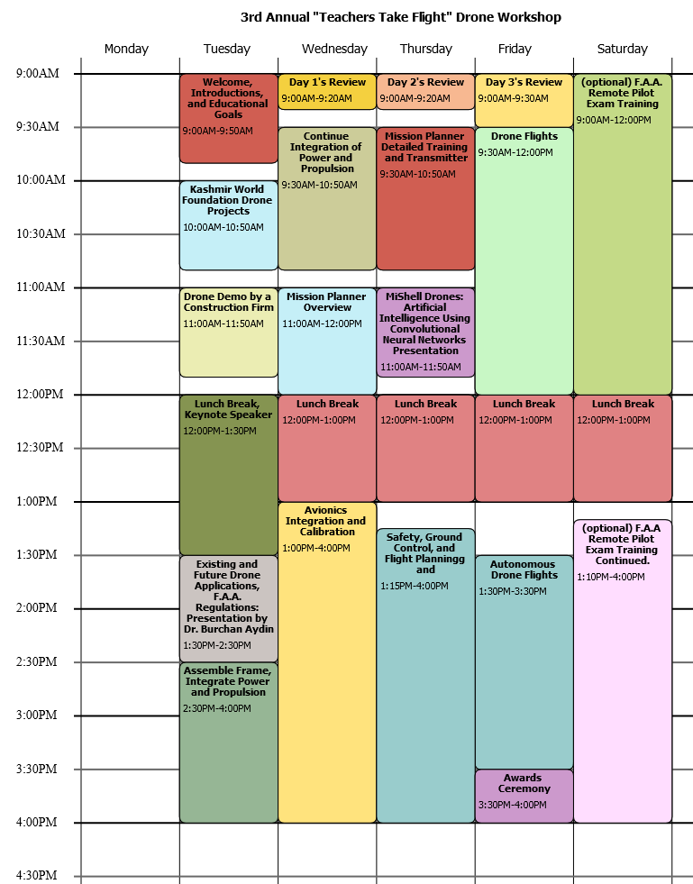

1. **Biographical Sketches**

The workshop will be led by subject matter experts from Kashmir World Foundation and Dr. Burchan Aydin, an assistant professor at A&M-Commerce Department of Engineering and Technology. Please see below brief bios of the workshop instructors.

**Princess Aliyah, Executive Director, Kashmir World Foundation**

Princess Aliyah Pandolfi is the Executive Director of Kashmir World Foundation. Princess Aliyah chose a path to provide an interdisciplinary education and means to achieve real world solutions through a global network of scientists, researchers, academics, engineers and students. A pioneer in education, the Princess has created mission focused programs that integrates art, science, and technology as enablers for innovation and invention. She has engaged individuals, organizations, business leaders, universities and governments throughout the world in collaboration to protect endangered wildlife, the broader earth ecosystem, and the role of our planet in an evolving cosmology.

Princess Aliyah is an inspirational and innovative inventor and educator with a vision to change the world through tools of knowledge. Drawing on her success in real estate, business, and international finance, Princess Aliyah founded Kashmir World Foundation in September 2008. Her approach is to enlighten through education and communications to make people aware of the broader context in which they live, and empower with technological inventions and financial infrastructures within which communities can flourish. Under the direction of Princess Aliyah, Kashmir World Foundation has developed a unique approach to help people evolve from dependency on others for basic necessities, to cultivating leaders within a sustainable community.

As a descendant of royals from Kashmir, a country struggling to combat poaching of endangered Snow Leopards, Princess Aliyah has a full understanding of the costs of poaching, habitat distruction, and challenge faced by conservationists.

**Dr. Ronald Pandolfi, Director of Kashmir Robotics**

Dr. Pandolfi has 30 years of extensive experience in the application of surveillance, communications, robotics, aircraft and weapons systems to counter poaching of endangered species. As founder and director of the Technology Assisted Counter Poaching TACP-network, he has been working behind the scenes for over 25 years equipping rangers and other ground forces with the tools needed to defeat poachers and the criminal organizations engaged in trafficking of endangered species.

Dr. Pandolfi designed and engineered the DaVinci Challenge multi-copter drone kits for educational and instructional purposes. He lectures students during workshops to collaborate using open source hardware and software for mission focused applications equipped with onboard processing through self-learning algorithms on single board computers and sensors integrated throughout their autonomous unmanned aerial systems.

**Dr. Burchan Aydin, Assistant Professor of Engineering and Technology, Texas A&M University-Commerce**

Dr. Aydin is an industrial engineering academician with a bachelor’s degree from Middle East Technical University, Ankara, Turkey, and a doctoral degree from Texas Tech University, Lubbock, TX. Besides industrial engineering degrees, he holds a master’s degree of organizational development from University of the Incarnate Word, San Antonio, TX. He is a U.S. Federal Aviation Administration (F.A.A.) licensed remote pilot for small unmanned air systems. His research emphasis is using unmanned air vehicles for firefighting including building and wildfires, granted by Texas A&M University Engineering Experiment Station (TEES). Dr. Aydin has been teaching for 3 years at A&M Commerce including subjects such as unmanned air vehicles for emergency and disaster response, unmanned air vehicles for commercial applications, economics, statistics, supply chain management, sustainability, emerging technologies, and project management.

1. **Budget and Budget Justification**

There will be a maximum of 7 teams, which means maximum 7 drones will be built during the workshop in order to provide a smooth learning experience for attendees. Each school can send additional teachers by a discounted fee as shown in Table-1. No matter how many teachers come from a specific school, they will build one drone per school during the workshop as a team. This is to prevent disarray during the flight tests.

Two of the seven teams will be selected from underprivileged local middle schools. Two teachers from each middle school will receive full scholarship for the workshop. These two teachers will build a quadcopter and take it back to their schools. Moreover, we are giving three additional drone kits to these teachers in order to give them the opportunity to repeat the process in their schools (one for each teacher, and one for their students). These scholarship costs are itemized in the budget. Based on the received grant, the scholarship number can be increased to 3 schools.

Moreover, the travel expenses of two instructors from Kashmir World Foundation and the estimated costs regarding meal, coffee, and snacks are itemized in the budget as well.

Part of the expenses will be met by the registration fees as listed in Table-1. This is a workshop organized by a non-profit organization, and a non-profit public university, thus any leftover funds will be used in the next year’s workshop.

Table 1-Registration Fees

|  |  |  |  |  |
| --- | --- | --- | --- | --- |
| **Drone Kit Options** | **Workshop Fee with Drone** | **Additional Teacher from Same School** | **Early Bird Discount** | **Early Bird Deadline** |
| Quadcopter | $1,295.00 | $495.00 | $100 | 1-Apr-18 |
| Hexacopter | $1,395.00 | $495.00 | $100 | 1-Apr-18 |

Table 2 itemizes the associated costs.

Table 2-Costs

|  |  |  |  |  |
| --- | --- | --- | --- | --- |
| ***Travel for (2) Instructors*** | **Description** | **Unit Cost** | **Quantity** | **Total** |
| Airfare | Flights from DCA to Dallas | $300.00 | 2 | $600.00 |
| Accommodations | 5 nights | $200.00 | 5 | $1,000.00 |
| Dinner (Lunch is included in the meal section of the budget) | 5 days | $100.00 | 5 | $500.00 |
| Car | 5 days | $300.00 | 1 | $300.00 |
| Gas | Approximate cost of travel during workshop. | $100.00 | 1 | $100.00 |
| Shipping | Cost to shop drone kits and transmitters. | $200.00 | 1 | $200.00 |
| Workshop locations | Contributed by A&M-Commerce |  |  | 0 |
|  |  |  | **Subtotal** | **$2,700.00** |
| **Scholarship for 2 Schools** | **Description** | **Cost** | **Quantity** | **Total** |
| Middleschool Teachers Workshop & Quadcopter Drone | Teachers will be selected from schools with 50% or higher free or reduced lunch students. The cost of the drone and indirect expenses | $1,295.00 | 2 | $2,590.00 |
| Additional Teacher with each team | Each school selected will have 2 teachers that would participate in the workshop. This will help school facilitate a drone program at their schools. The total number of teachers that will receive training will be 6 plus 3 drones kits. | $495.00 | 2 | $990.00 |
| Additional Drone Kits | Teachers who participate in the program will be given additional drones to start the program at their schools. | $500.00 | 6 | $3,000.00 |
|  |  |  | **Subtotal** | **$6,580.00** |
| **Meals and Coffee breaks** | **Description** | **Cost per attendee per day** | **Quantity** | **Total** |
| Lunch |  | $15 | 4 lunches per around 20 person | $1,200 |
| Coffee and Snacks |  | $5 | 8 coffee breaks per around 20 person | $800 |
|  |  |  | **Subtotal** | **$2,000.00** |
| **TOTAL** | | | | **$11,280.00** |

**Requested Amount:** In order to be able conduct the workshop even under worst case scenario, we are asking for a grant of $8,000. This value is calculated as follows:

Worst-Case Scenario: Schools don’t send additional teachers; thus total 5 teachers attend (excluding the teachers with scholarship). These five teachers select building a quadcopter.

5 X $1295= $6475 gross revenue from registration fees.

However $500 per registration will go to the drone kit preparation. Thus overall revenue will be only:

5 x ($1295-$500) = $3975 net revenue.

Total cost of the workshop is estimated to be $11,280 as shown in Table 2.

The difference between the total cost and net revenue is $7,305. To also account for any miscellaneous expenses, it is rounded up to **$8,000**.

As mentioned earlier, any leftover funds will be used for the following workshop. This workshop is organized by non-profit organizations.

1. **Drone Kits**

Could you write the items on the drone kits? I am sure you have these handy from last year, also any additional info, we can even talk about previous workshops/

1. **References**

[1] S. L. MacSween-George, A public opinion survey-unmanned aerial vehicles for cargo, commercial, and passenger transportation, 2nd American Institute of Aeronautics and Astronautics (AIAA) “Unmanned Unlimited” Systems, Technologies, and Operations-Aerospac, 2003.

[2] S. L. MacSween-George, Will the public accept UAVs for cargo and passenger transportation?, Proceedings of the IEEE Aerospace Conference, Vol. 1, IEEE Publications, Piscataway, NJ, 2003, pp. 357–367.

[3] B. Rao, A. G. Gopi, R. Maione, The societal impact of commercial drones, Technology in Society 45 (2016) 83-90.

[4] C. Lidynia, R. Philipsen, M. Ziefle, Droning on about drones-acceptance of and perceived barriers to drones in civil usage contexts, in: P. Savage-Knepshield, J. Chen (Eds.), Advances in Human Factors in Robots and Unmanned Systems, Advances in Intelligent Systems and Computing, 499, . Springer, Switzerland, 2017, pp. 317-329.

[5] P. Boucher, You wouldn’t have your granny using them: drawing boundaries between acceptable and unacceptable applications of civil drones, Sci. Eng. Ethics 22 (2016) 1391-1418.

[6] Kashmir World Foundation, <https://www.kashmirworldfoundation.org/>